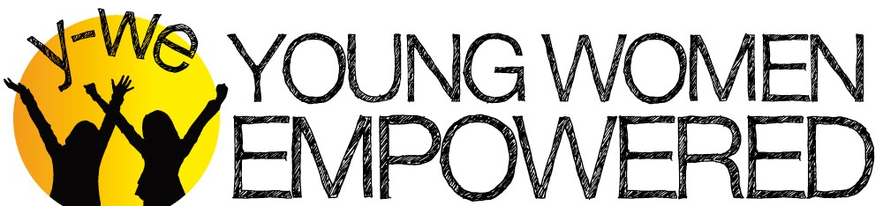
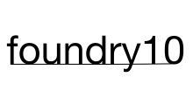
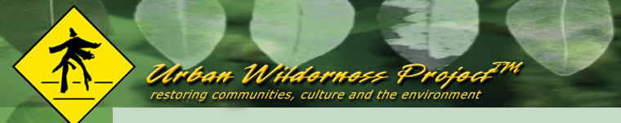

Young Women Empowered, foundry10, and Urban Wilderness Project LLC Hold Harmless Release Form
PLEASE REVIEW CAREFULLY AND SIGN AND INITIAL WHERE INDICATED.

I would like to serve as a Mentor, Volunteer or Teaching Artist for Y-WE Lead 9/12/15-6/12/15

Release: I agree to release and hold harmless Young Women Empowered (Y-WE), Partnership for Youth Empowerment Global (PYE), foundry10, LLC (foundry10), and Urban Wilderness Project, their respective employees, officers and agents, and any leaders of Y-WE, PYE, foundry10, and Urban Wilderness Project from any and all responsibility and liability of any nature that may arise during the program, including but not limited to any claims for personal injury or property damage.

Research: I understand that foundry10 and Urban Wilderness Project are assisting with Y-WE’s program and may be conducting research, including interviews and/or performance measurements, as part of the program. I authorize foundry10 and Urban Wilderness Project to use the results of such research in furtherance of foundry10’s and Urban Wilderness Project’s business, with the understanding that foundry10 and Urban Wilderness Project will not specifically identify me in any such results. I assign to foundry10 and Urban Wilderness Project all rights to such research and release foundry10, Urban Wilderness Project, and their officers, employees and agents from any claims arising out of its use.

Insurance: It is the responsibility of every individual to provide for his or her own accident and health coverage while participating in any Y-WE activities. I understand that Y-WE does not provide any accident or health coverage for its volunteers, mentors, or otherwise.

Valuables: I understand that personal items that are misplaced or lost at Y-WE’s program are the responsibility of the participants and volunteers, not Y-WE, PYE, foundry10, or Urban Wilderness Project.

Photo and Video Release: I give permission to Y-WE, or those who have the written consent of Y-WE, including foundry10 and Urban Wilderness Project, to use photos or videos of me for purposes of promoting Y-WE programs or in furtherance of foundry10’s and Urban Wilderness Project’s business. This includes the consent to modify, edit, and reuse a photo or video. I expressly release Y-WE, foundry10, Urban Wilderness Project, and their respective agents, employees, licensees, and assigns from any and all claims which I have or may have for invasion of privacy, defamation, or any other cause of action arising out of the use of these photographs and video.

I certify that the information I have supplied is correct to the best of my knowledge. I grant permission for Young Women Empowered to contact the references provided. I also agree to hold Young Women Empowered and those persons who are contacted in connection with my application harmless from any legal claim regarding compliance with the request for references.

I also agree to have Young Women Empowered conduct a criminal background check with the Washington State Patrol and the National Sex Offender Search (This is required for anyone who works with youth). Your Initials:

I understand that the terms of this agreement are intended to be binding and shall be governed by the laws of the State of Washington.

Signature Date

Print Name_____________________________________

Thank you for your interest in supporting Y-WE!

Scan and email a copy to programs@y-we.org OR mail a hard-copy of this page, with all initials and your signature, to:
Young Women Empowered
316 4th Ave. South
Kirkland, WA 98033
Questions? Contact our office at: (425) 242-0187 programs@y-we.org

