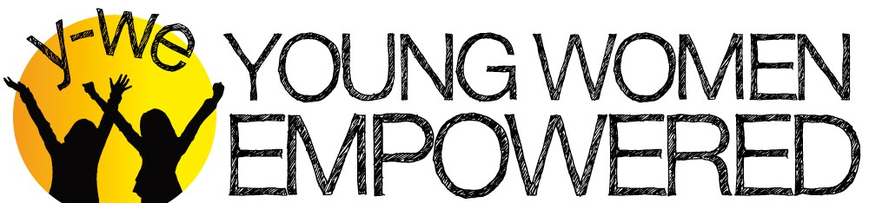
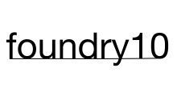
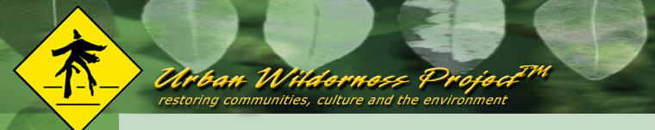

Y-WE Youth, foundry10, and Urban Wilderness Project LLC
Hold Harmless Release Form
PLEASE initial after each paragraph where indicated

I permit my youth to participate in the Young Women Empowered Leadership Program. (Initial) _______

Release: I agree to release and hold harmless Young Women Empowered (Y-WE), Partnership for Youth Empowerment (PYE), foundry10, LLC (foundry10), and Urban Wilderness Project, their respective employees, officers and agents, and any leaders of Y-WE, PYE, foundry10, and Urban Wilderness Project from any and all responsibility and liability of any nature that may arise during the program, including, but not limited to, any claims for personal injury or property damage. This release includes any liability which may arise if my youth leaves the grounds of the program without authorization, or otherwise goes against the basic program guidelines. (Initial) _______

Research: I understand that foundry10 and Urban Wilderness Project are assisting with Y-WE’s program and may be conducting research, including interviews and/or performance measurements, as part of the program. I authorize foundry10 and Urban Wilderness Project to use the results of such research in furtherance of foundry10’s and Urban Wilderness Project’s business, with the understanding that foundry10 and Urban Wilderness Project will not specifically identify my youth in any such results. I assign to foundry10 and Urban Wilderness Project all rights to such research and release foundry10 and Urban Wilderness Project and its officers, employees and agents from any claims arising out of its use. (Initial) _______

Insurance: It is the responsibility of every individual, through her parent or legal guardian, to provide for her own accident and health coverage while participating in any Y-WE activities. I understand that Y-WE does not provide any accident or health coverage for its participants. (Initial) _______

Participation: I give permission for my youth to participate in activities, field trips, overnight retreats, and to be transported in vans or private automobiles as authorized by Y-WE. (Initial) _______

Valuables: I understand that personal items that are misplaced or lost at Y-WE’s program are the responsibility of the participant, not Y-WE, PYE, foundry10, or Urban Wilderness Project. (Initial) _______

Photo and Video Release: I give permission for Y-WE, or those who have the written consent of Y-WE, including foundry10 and Urban Wilderness Project, to use photos or videos of my youth for purposes of promoting Y-WE programs or in furtherance of foundry10’s or Urban Wilderness Project’s business. This includes the consent to modify, edit, and reuse a photo or video. I expressly release Y-WE, foundry10, Urban Wilderness Project and their respective agents, employees, licensees, and assigns from any and all claims which I have or may have for invasion of privacy, defamation, or any other cause of action arising out of the use of these photographs and video. (Initial) _______

Governing Provision. I understand that the terms of this agreement are intended to be binding and shall be governed by the laws of the State of Washington. (Initial) _______

Does your youth have a history of behavioral or other problems such as substance abuse, involvement with the criminal justice system or mental health issues of which we should be aware? No______ Yes_______
If so, please or email our office. We want to ensure that Y-WE is a safe and supportive environment for all participants and that we are aware of your youth’s specific needs. Y-WE is not able to provide programs for youth who may seriously endanger themselves or others during our events.

I have read, initialed, and understand the above and have completed it to the best of my ability.
Participant’s Name: ________________________________________________________________
Participant’s Signature (if 18 or over): ________________________________________________
Parent or Guardian Name (Please Print): _____________________________________________
Parent or Guardian Signature: ______________________________________________________
Date: ____________________

